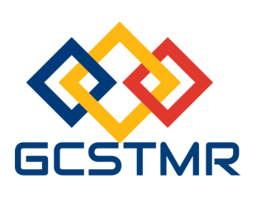
Global Circle for Scientific, Technological and Management Research (GCSTMR)
12 Boyer Pl, Minto, NSW 2566, Sydney, Australia
==========================================================
International Conference on Advancements in Engineering Education (iCAEED)
20-23 November 2024, Sydney, Australia
(REGISTRATION FORM)
Please complete this registration form and email the completed form to secretary@gcstmr.org.au. A receipt of payment will then be emailed to you.
Paper ID
Paper Title
Registrant details | Name:  Address:  Email:  Contact Telephone No:
Registration Type (Please tick) | - Full registration - Early bird: $995 Bird on time: $1095  - Student registration - Early bird: $650 Bird on time: $750  - Daily registration (for one day) - Early bird: $600 Bird on time: $700  - Accompanying family member - Early bird: $400 Bird on time: $400  - Conference dinner: $130  Early bird rate closes on 30 Sep 2024. Bird on time closes on 10 Nov 2024
Total Amount paid
Registration date
(For daily registrant)
Transaction ID
(Payment details)

